Week 4

Raoul Nedermeijer en Tjorn Brederoo

*Klas 1 Damion Gans*

# Inhoudsopgave

**Inhoudsopgave 2**

**4.1 3**

Feiten 3

Dimensietabellen 3

**4.2 8**

Feiten 8

Feit tabellen 8

Afgeleide meetwaarden 9

SALES_TARGET_Data 9

order_details 9

GO_SALES_PRODUCT_FORECAST 9

Ster schema 10

**4.3 11**

ETL-Schema’s 11

# 4.1

## Feiten

Uit ons gegevensmodel hebben wij de volgende feiten gehaald, met de bijbehorende dimensies:

* order_details
  + *product*
  + *returned_item*
* order_method
  + *heeft geen dimensies*
* order_header
  + *retailer_site*
  + *sales_branch*
  + *sales_staff*
* training
  + *course*
  + *sales_staff*
* satisfaction
  + *satisfaction_type*
  + *sales_staff*
* SALES_TARGETData
  + *sales_staff*
  + *product*
  + *retailer*
* GO_SALES_INVENTORY_LEVELS
  + *product*
* GO_SALES_PRODUCT_FORECAST
  + *product*

## Dimensietabellen

| Product | | | | | | |
| --- | --- | --- | --- | --- | --- | --- |
| INTRODUCTION_DATE  date | PRODUCTION_COST  number | MARGIN  number | LANGUAGE  string | **MINIMUM_SALE_PRICE**  number | PRODUCT_LINE  product_line_code, product_line_code_en | PRODUCT_TYPE  product_type_code, product_type_en |
| Product  product_number, product_name, description, product_image | | | | | | |

| Returned_item | | | | |
| --- | --- | --- | --- | --- |
| RETURN_DATE  Date | RETURN_QUANTITY  Number | ORDER_DETAIL_CODE  string | RETURN_REASON  return_reason_code, return_description_en | **RETURNED_ITEMS_TOTAL_PRICE**  **number** |
| RETURNED_ITEM  return_code | | | | |

| SALES_STAFF | | | | | | | | | | | | | | | |
| --- | --- | --- | --- | --- | --- | --- | --- | --- | --- | --- | --- | --- | --- | --- | --- |
| POSITION_EN  name | | | WORK_PHONE  number | | | DATE_HIRED  date | | | MANAGER_CODE  string | | | FAX  number | SALES_BRANCH  sales_branch_code, address, adress_extra | first_name  string | last_name  string |
| **full_name**  string | |
| SALES_STAFF  sales_staff_code, email, extension | | | | | | | | | | | | | | | |

| COURSE | | | |
| --- | --- | --- | --- |
| COURSE  course_code, course_description, **course_description_short** | | | |

| COUNTRY | | | | |
| --- | --- | --- | --- | --- |
| SALES_TERRITORY  sales_territory_code, territory_name_en | | | LANGUAGE  name | CURRENCY  name |
| COUNTRY  country_code, name, flag_image | | | | |

Bij Country is er geen afgeleide. Er is hiervoor te weinig informatie.

| RETAILER | |
| --- | --- |
| COMPANY_CODEMR  code | RETAILER_TYPE  retailer_type_code, retailer_type_EN |
| RETAILER  retailer_code, retailer_name | |

Bij retailer past geen afgeleide. Er is geen beschrijving om in te korten en retailet_type geld al al groepering.

| RETAILER_SITE | | | | |  |  |  |  |
| --- | --- | --- | --- | --- | --- | --- | --- | --- |
| COUNTRY_CODE code | | | RETAILER_CODE code | ACTIVE INDICATOR boolean | ADDRESS1  address | ADDRESS2  address | ADDRESS3  address | **MAIN_ADDRESS**  **string** |
| CITY name | | |
| REGION name | | |
| POSTAL_ZONE code | | |
| RETAILER_SITE  retailer_site_code | | | | |  |  |  |  |

| RETAILER_CONTACT | | | | | | | | | | | | | | | | | |
| --- | --- | --- | --- | --- | --- | --- | --- | --- | --- | --- | --- | --- | --- | --- | --- | --- | --- |
| RETAILER_SITE_CODE  code | | | | JOB_POSITION_EN  name | | | | EXTENSION  number | | | FAX  number | | GENDER  string | | FIRST_NAME  string | LAST_NAME  string | **FULL_NAME**  string |
| RETAILER_CONTACT  retailer_contact_code, e_mail | | | | | | | | | | | | | | | | | |

| RETAILER_HEADQUARTERS | | | | | | | | |
| --- | --- | --- | --- | --- | --- | --- | --- | --- |
| COUNTRY_CODE code | PHONE  number | | FAX  number | | SEGMENT_CODE  code | | address1 | address2 |
|
| REGION name |
|
| CITY  name |
| **main_address**  **string** | |
| POSTAL_ZONE  code |
|
|
|
| RETAILER_HEADQUARTERS  retailer_codemr, retailer_name | | | | | | | | |

| RETAILER_SEGMENT |
| --- |
| language  name |
| RETAILER_SEGMENT  segment_code, segment_name, segment_description, **segment_description_short** |

| SATISFACTION_TYPE |
| --- |
| SATISFACTION_TYPE  satisfaction_type_code, satisfaction_type_description, **satisfaction_type_description_short** |

| SALES_BRANCH | | | |
| --- | --- | --- | --- |
| COUNTRY_CODE code | | ADDRESS1  address | ADDRESS2  address |
| **main_address**  **string** | |
| REGION name | | | |
| CITY  name | | | |
| POSTAL_ZONE  code | | | |
| RETAILER_HEADQUARTERS  sales_branch_code | | | |

| SALES_BRANCH | | | | |
| --- | --- | --- | --- | --- |
| COUNTRY_CODE code | | ADDRESS1  address | ADDRESS2  address | **main_address**  **string** |
| REGION  regio | |
| CITY  stad | |
| POSTAL_ZONE  postal_zone | |
| RETAILER_HEADQUARTERS  sales_branch_code | | | | |

# 4.2

## Feiten

Uit ons gegevensmodel hebben wij de volgende feiten gehaald:

* order_details
* order_method
* order_header
* training
* satisfaction
* SALES_TARGETData
* GO_SALES_INVENTORY_LEVELS
* GO_SALES_PRODUCT_FORECAST

## Feit tabellen

Van deze feiten hebben we feit tabellen gemaakt. Paars zijn de primary keys, groen meetwaarden en oranje zijn foreign keys.

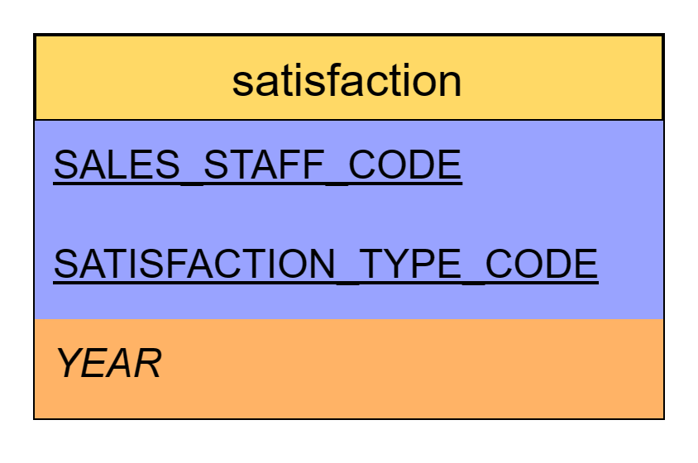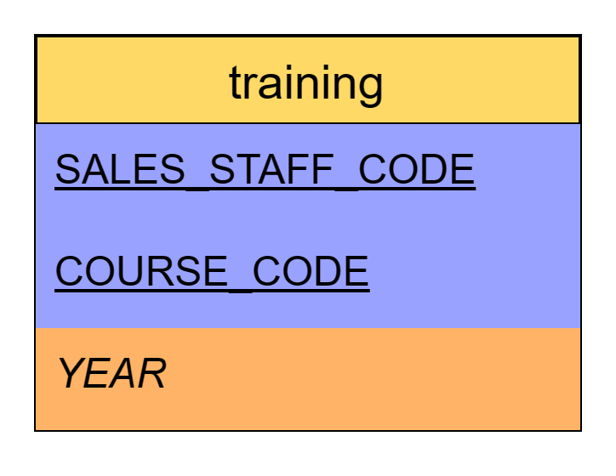

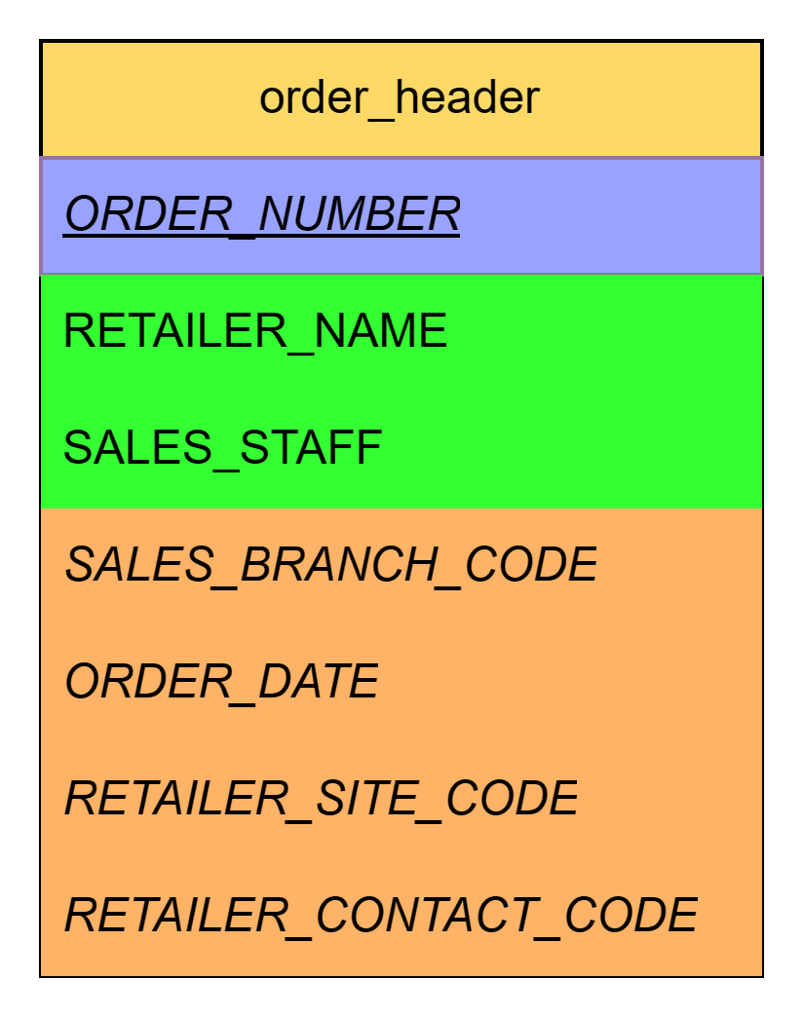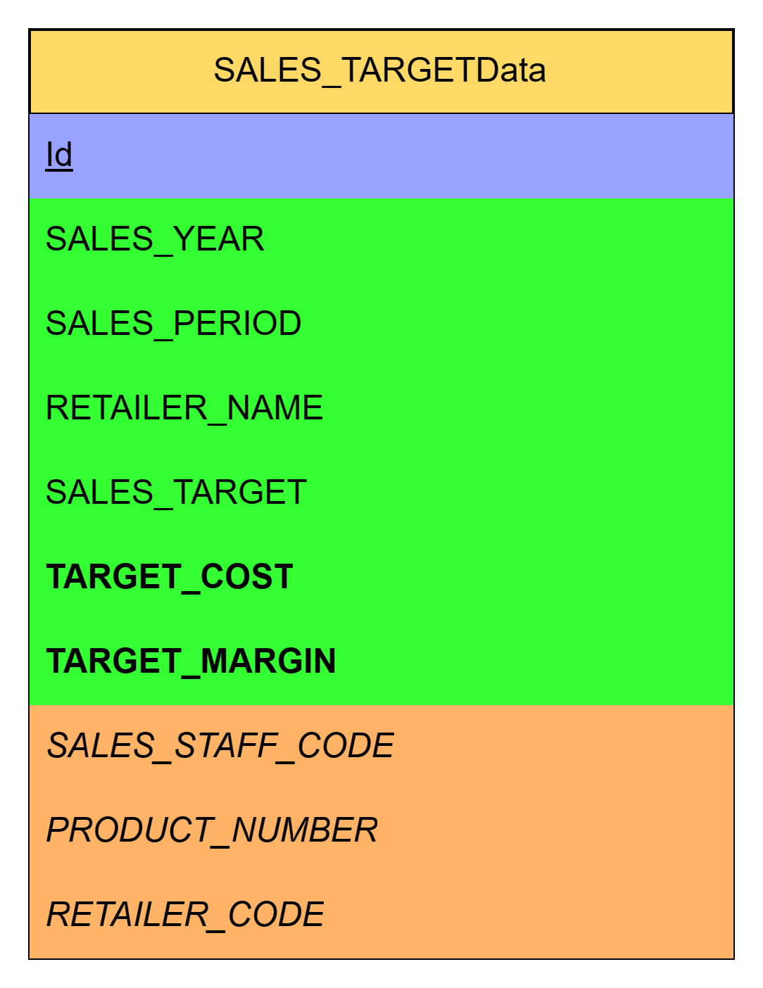

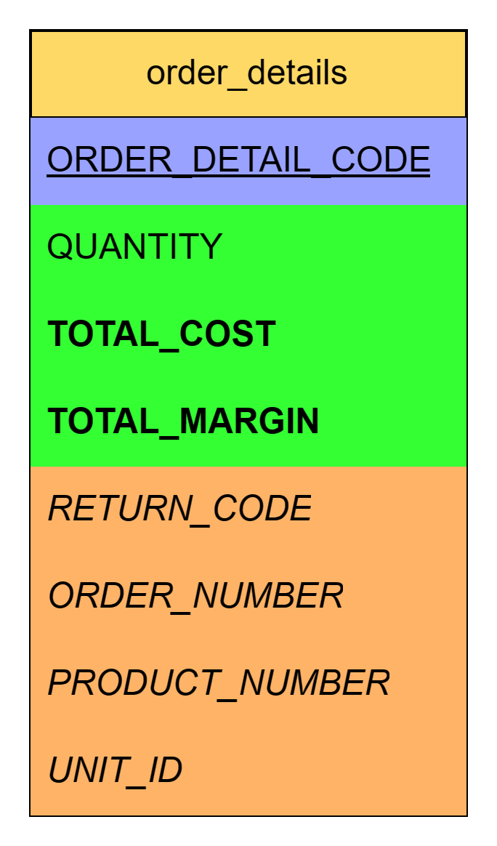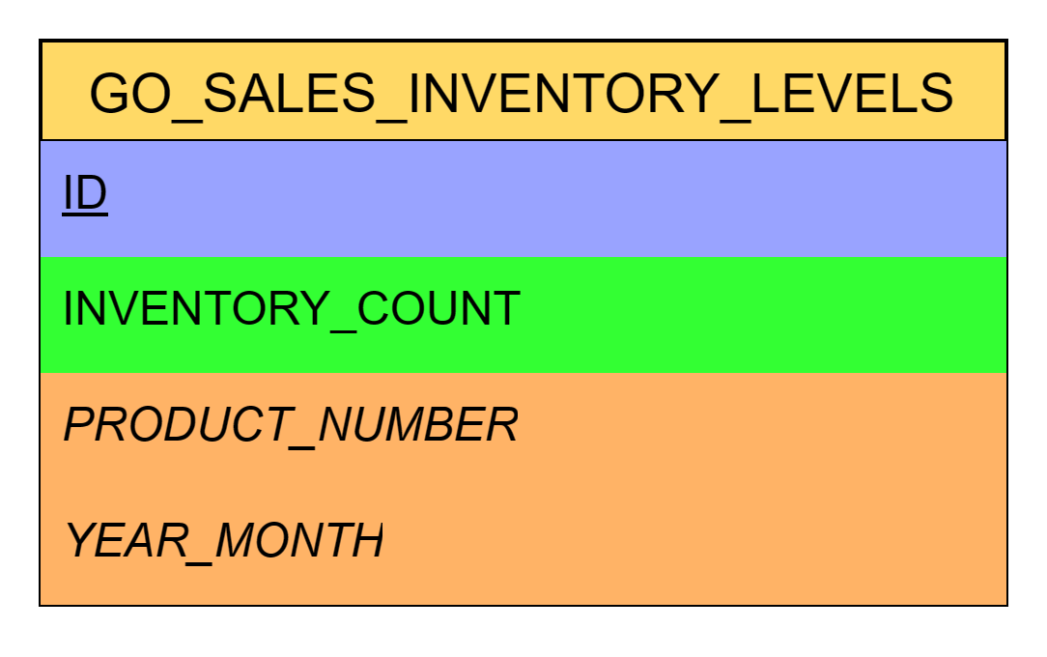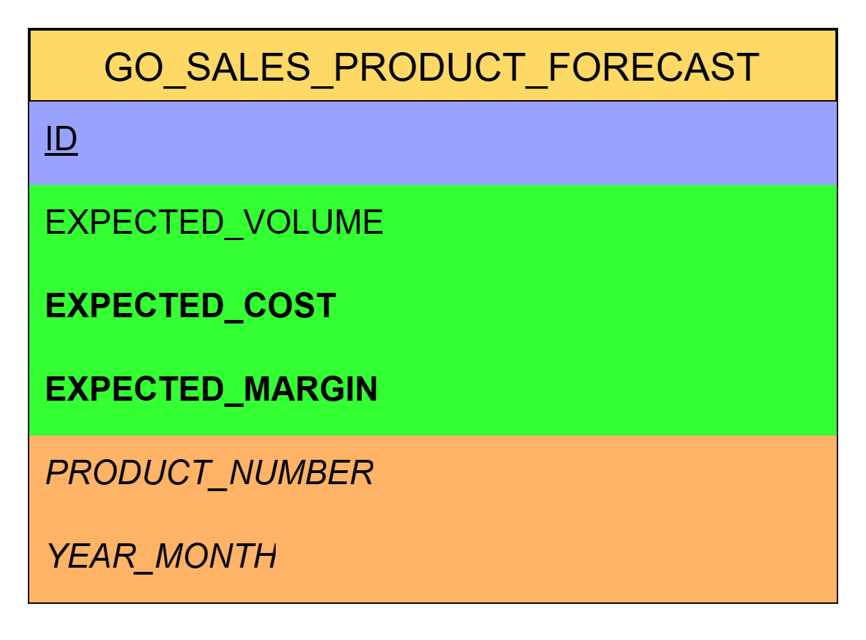

### Afgeleide meetwaarden

De dikgedrukte groene velden zijn afgeleide meetwaarden.

#### SALES_TARGET_Data

* TARGET_COST geeft inzicht in hoeveel de sales target gaat kosten qua producten
  + Wordt gemaakt door SALES_TARGET en PRODUCTION_COST te vermenigvuldigen
* TARGET_MARGIN geeft inzicht in het verwachte totale marge voor de sales target
  + Wordt gemaakt door SALES_TARGET en MARGIN te vermenigvuldigen

#### order_details

* TOTAL_COST geeft inzicht in de totale productie kosten voor de order
  + Wordt berekent door QUANTITY te vermenigvuldigen met PRODUCTION_COST
* TOTAL_MARGIN geeft inzicht in de margin van de order.
  + Wordt berekent door QUANTITY te vermenigvuldigen met MARGIN

#### GO_SALES_PRODUCT_FORECAST

* EXPECTED_COST geeft inzicht in de verwachte kosten voor de periode.
  + Berekend door EXPECTED_VOLUME te vermenigvuldigen met PRODUCTION_COST
* EXPECTED_MARGIN geeft inzicht in de verwachte margin voor de periode.
  + Berekend door EXPECTED_VOLUME te vermenigvuldigen met MARGIN

## 

## Ster schema

Dit alles leidt tot het volgende ster schema:

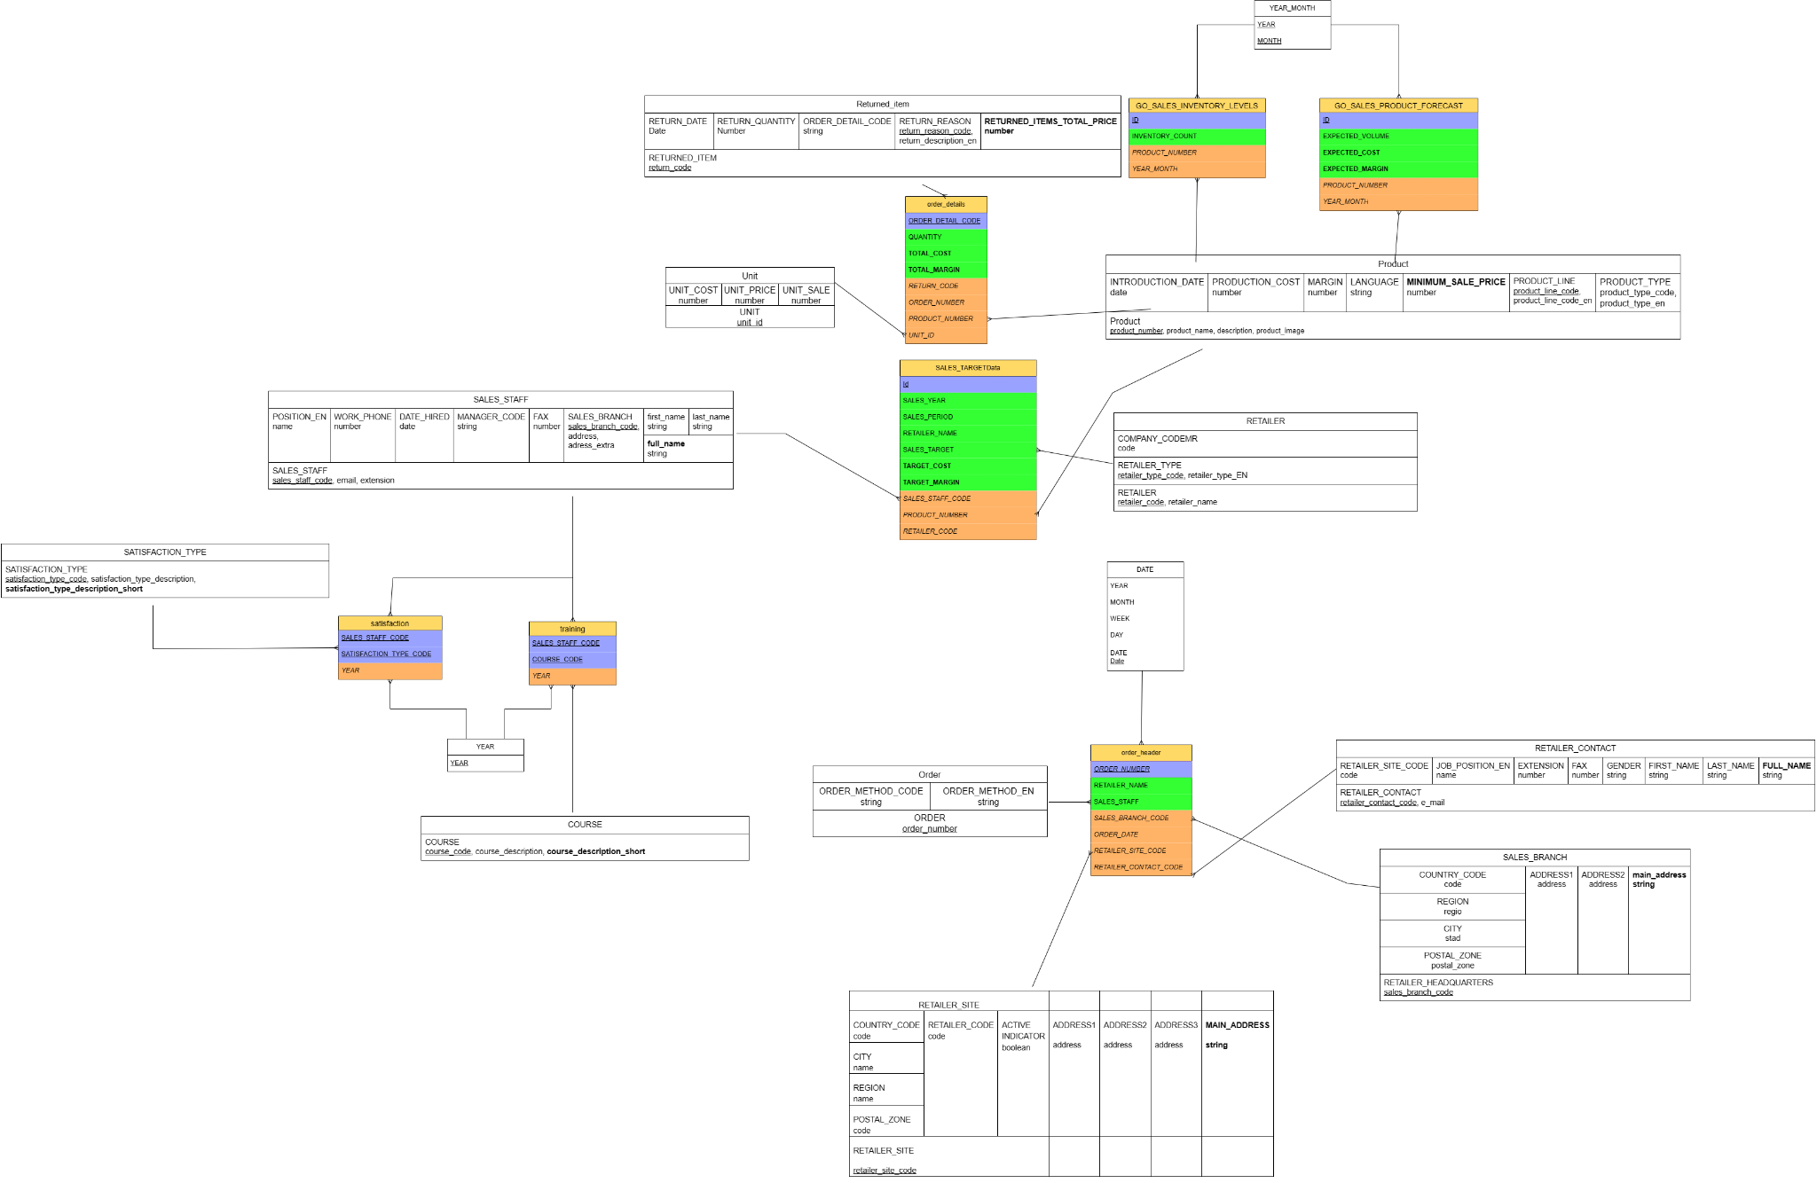

# 4.3

* + Maak een database in SSMS, dit wordt je uiteindelijke Data Warehouse.
  + Maak een ETL-schema van elke tabel in het Sterschema.
  + Implementeer elk gemaakt ETL-schema in Python (met Jupyter Notebook). Gebruik hierbij de technische informatie uit week 2.
  + Zorg er ten slotte voor dat je het Sterschema en elk ETL-schema aan je portfolio hebt toegevoegd. Hier word je in week 6 op beoordeeld.

## ETL-Schema’s

| **Returned_item** |
| --- |
| RETURNED_ITEM_code  RETURNED_ITEM_DATE_date  RETURNED_ITEM_QUANTITY_quantity  RETURNED_ITEM_ORDER_DETAIL_CODE_detail_code  RETURNED_ITEM_RETURN_REASON_code  RETURNED_ITEM_RETURN_REASON_desctiption_en  RETURNED_ITEM_RETURNED_ITEMS_TOTAL_PRICE_total |

| **Unit** |
| --- |
| UNIT_id  UNIT_COST_cost  UNIT_PRICE_price  UNIT_SALE_sale |

| **Sales_staff** |
| --- |
| SALES_STAFF_code  SALES_STAFF_FIRST_NAME_first_name  SALES_STAFF_LAST_NAME_last_name  SALES_STAFF_FULL_NAME__full_name  SALES_STAFF_POSITION_EN_position  SALES_STAFF_WORK_PHONE_work_phone  SALES_STAFF_extension  SALES_STAFF_FAX_fax  SALES_STAFF_email  SALES_STAFF_DATE_HIRED_hired  SALES_STAFF_SALES_BRANCH_CODE_branch_code  SALES_STAFF_MANAGER_CODE_manager  SALES_STAFF_SALES_BRANCH_ADDRESS_address  SALES_STAFF_SALES_BRANCH_ADDRESS_EXTRA_address_extra |

| **Satisfaction_type** |
| --- |
| SATISFACTION_TYPE_code  SATISFACTION_TYPE_description  SATISFACTION_TYPE_description_short |

| **Course** |
| --- |
| COURSE_code  COURSE_description  COURSE_description_short |

| **Year** |
| --- |
| YEAR |

| **Date** |
| --- |
| DATE_date  DATE_YEAR_year  DATE_MONTH_month  DATE_DAY_day |

| **Order** |
| --- |
| ORDER_order_number  ORDER_ORDER_METHOD_CODE_method_code  ORDER_ORDER_METHOD_EN_method |

| **Retailer_site** |
| --- |
| RETAILER_SITE_code  RETAILER_SITE_RETAILER_CODE_retailer_code  RETAILER_SITE_ADDRESS1_address  RETAILER_SITE_ADDRESS2_address  RETAILER_SITE_CITY_city  RETAILER_SITE_REGION_region  RETAILER_SITE_POSTAL_ZONE_postal_zone  RETAILER_SITE_COUNTRY_CODE_country  RETAILER_SITE_ACTIVE_INDICATOR_indicator  RETAILER_SITE_MAIN_ADDRESS_address |

| **Sales_branch** |
| --- |
| SALES_BRANCH_code  SALES_BRANCH_ADDRESS1_address  SALES_BRANCH_ADDRESS2_address  SALES_BRANCH_MAIN_ADDRESS_address  SALES_BRANCH_CITY_city  SALES_BRANCH_REGION_region  SALES_BRANCH_POSTAL_ZONE_postal_zone  SALES_BRANCH_COUNTRY_CODE_country |

| **Retailer_contact** |
| --- |
| RETAILER_CONTACT_code  RETAILER_CONTACT_RETAILER_SITE_CODE_site_code  RETAILER_CONTACT_FIRST_NAME_first_name  RETAILER_CONTACT_LAST_NAME_last_name  RETAILER_CONTACT_FULL_NAME_full_name  RETAILER_CONTACT_JOB_POSITION_EN_position  RETAILER_CONTACT_EXTENSION_extension  RETAILER_CONTACT_FAX_fax  RETAILER_CONTACT_email  RETAILER_CONTACT_GENDER_gender |

| **Retailer** |
| --- |
| RETAILER_code  RETAILER__name  RETAILER_COMPANY_CODEMR_company  RETAILER_RETAILER_TYPE_retailer_type_code  RETAILER_RETAILER_TYPE_retailer_type_EN |

| **Product** |
| --- |
| PRODUCT_number  PRODUCT_INTRODUCTION_DATE_introduced  PRODUCT_PRODUCT_TYPE_code  PRODUCT_PRODUCT_TYPE_code_en  PRODUCT_PRODUCTION_COST_cost  PRODUCT_MARGIN_margin  PRODUCT_image_image  PRODUCT_LANGUAGE_language  PRODUCT_name_product  PRODUCT_description_description  PRODUCT_MINIMUM_SALE_PRICE_minPrice  PRODUCT_PRODUCT_LINE_code  PRODUCT_PRODUCT_LINE_code_en |

| **Order_details** |
| --- |
| ORDER_DETAILS_code  ORDER_DETAILS_ORDER_NUMBER_order  ORDER_DETAILS_PRODUCT_NUMBER_product  ORDER_DETAILS_QUANTITY_quantity  ORDER_DETAILS_TOTAL_COST_total  ORDER_DETAILS_TOTAL_MARGIN_margin  ORDER_DETAILS_RETURN_CODE_returned  ORDER_DETAILS_UNIT_ID_unit |

| **SALES_TARGETData** |
| --- |
| SALES_TARGETDATA_id  SALES_TARGETDATA_SALES_YEAR  SALES_TARGETDATA_SALES_PERIOD  SALES_TARGETDATA_RETAILER_NAME  SALES_TARGETDATA_SALES_TARGET  SALES_TARGETDATA_TARGET_COST  SALES_TARGETDATA_TARGET_MARGIN  SALES_TARGETDATA_SALES_STAFF_CODE  SALES_TARGETDATA_PRODUCT_NUMBER  SALES_TARGETDATA_RETAILER_CODE |

| **Training** |
| --- |
| TRAINING_SALES_STAFF_CODE  TRAINING_COURSE_CODE  TRAINING_YEAR |

| **Satisfaction** |
| --- |
| SATISFACTION_SALES_STAFF_CODE  SATISFACTION_SATISFACTION_TYPE_CODE  SATISFACTION_YEAR |

| **Order_header** |
| --- |
| ORDER_HEADER_number  ORDER_HEADER_RETAILER_NAME  ORDER_HEADER_RETAILER_SITE_CODE  ORDER_HEADER_RETAILER_CONTACT_CODE  ORDER_HEADER_SALES_STAFF  ORDER_HEADER_SALES_BRANCH_CODE  ORDER_HEADER_ORDER_DATE |

| **GO_SALES_INVENTORY_LEVELS** |
| --- |
| GO_SALES_INVENTORY_LEVELS_id  GO_SALES_INVENTORY_LEVELS_INVENTORY_COUNT  GO_SALES_INVENTORY_LEVELS_PRODUCT_NUMBER  GO_SALES_INVENTORY_LEVELS_YEAR_MONTH |

| **GO_SALES_PRODUCT_FORECAST** |
| --- |
| GO_SALES_PRODUCT_FORECAST_id  GO_SALES_PRODUCT_FORECAST_EXPECTED_VOLUME  GO_SALES_PRODUCT_FORECAST_EXPECTED_COST  GO_SALES_PRODUCT_FORECAST_EXPECTED_MARGIN  GO_SALES_PRODUCT_FORECAST_PRODUCT_NUMBER GO_SALES_PRODUCT_FORECAST_YEAR_MONTH |

| **Retailer_headquarters** |
| --- |
| RETAILER_codemr  RETAILER_name  RETAILER_ADDRESS1 address  RETAILER_ADDRESS2 address  RETAILER_CITY_city  RETAILER_REGION_region RETAILER_POSTAL_ZONE_postalzone  RETAILER_COUNTRY_CODE_country  RETAILER_PHONE_phone RETAILER_FAX_fax RETAILER_SEGMENT_CODE_segment |

| **Retailer_segment** |
| --- |
| SEGMENT_code  SEGMENT_LANGUAGE_language  SEGMENT_NAME_name  SEGMENT_DESCRIPTION_description |

[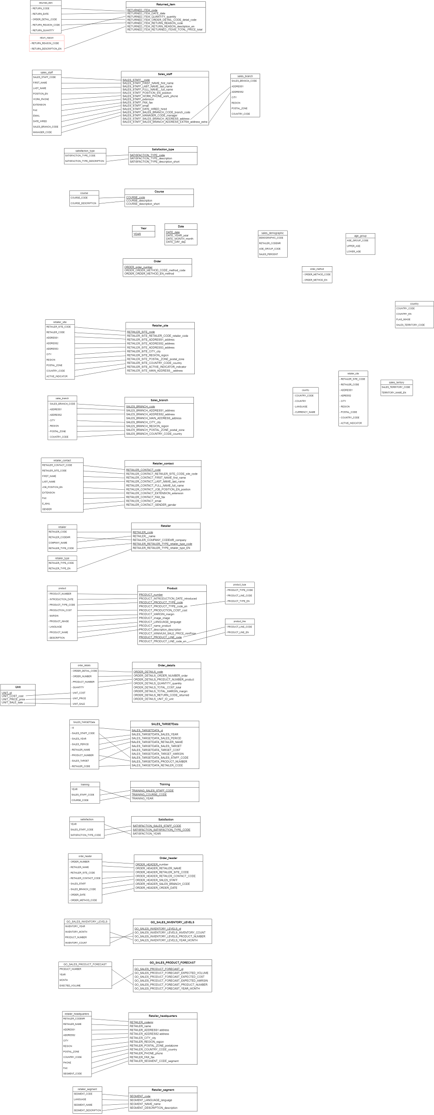](https://app.diagrams.net/?page-id=G1GNlizRW6fp0WgC6aS4&scale=auto#G1PZEfwaI_qT_g_W1ekZrJiM0-iGgiBz2A)